Functional Specification

shipping (SSCC) labels

1 General Information 3

2 Purpose 4

3 Functional Requirement 4

4 Solution Summary 4

5 Test Plan 4

6 Solution Details 5

# General Information

**Admin Info**

|  |  |
| --- | --- |
| **Purpose** | Print SSCC labels to affix to the container/carton |
| **Requested By** | Bridget |
| **Spec Created By** | Varun Gaddam |
| **Spec Creation Date** | 8/8/2023 |
| **Spec QA by** |  |
| **Objects** | Delivery Header and Item (LIKP, LIPS) |
| **Document Status** | WIP |

**References**

*[Attach any document(s) received for requirements]*

WIP

Teams’ location for all labels:

WIP

**Spec Changes**

*[List the changes made to the program after the approval of the original requirement, along with the Date on which the change request was received and the name of the initiator]*

|  |  |  |  |  |
| --- | --- | --- | --- | --- |
| **SI.** | **Change Details** | **Requested By** | **Requested On** | **Notes If any** |
| 1 | Adding Single Package Delivery | Bridget | 8/13/2024 |  |

| **Category** | **Name** | **Date** | **Sign-off** |
| --- | --- | --- | --- |
| Solution Architect | Navin Chaubey | 8/23/2023 |  |
| SAP EWM Lead | Varun Gaddam | 8/23/2023 |  |
| Business Owner | Bridget Hayes | 8/23/2023 |  |

# Purpose

Purpose/Why:

*[Explain the purpose of the project and the reason why this requirement has come]*

Customer Shipping (SSCC) labels provide detailed information about the carton's contents. They are required for regulatory purposes when shipping products from manufacturing locations nationwide.

Customer-specific SSCC has two types of Labels:

1. LTL/TL SSCC
2. Parcel SSCC

Customer-specific information will be sent, though. XML. The bartender will generate the customer-specific final label.

# Functional Requirement

**In Scope**

*[List the activities to be included in Scope]*

1. **LTL/TL**

The Picker completes the PICK HU task at the RF-GUN. The HU triggers through the PFF action custom program check the custom table ZTEWM_FORMPRINT to generate a .xml file, including label information and SSCC code Information.

Note: 1) If the LTL delivery is canceled, Manually SSCC NO Cancel App to delete the Delivery from the custom table (ZSCWM_SSCC_NO).

**The Process Types for the LTL Orders:**

2010 for Regular customers, orders will go to the Pallet area & Pull line area.

2013 for Special customers, orders will only go to the Pull line area.

There are three types of Delivery Level Counts:

1. Delivery Carton 🡪 Product Carton Count
2. Carton Count 🡪 Delivery Running Count
3. Total Delivery 🡪 Delivery Carton Count

However, the generation program should be able to generate the SSCC number from the function module to update the custom table and store it with additional information, as mentioned below.

|  |  |  |  |  |  |  |  |  |  |  |  |  |  |  |  |  |  |
| --- | --- | --- | --- | --- | --- | --- | --- | --- | --- | --- | --- | --- | --- | --- | --- | --- | --- |
| WHN | MATERIAL | CARTON SSCC | Pallet HU | Warehouse order | WPT | Delivery | ITEM | SHIPMENT | Qty | BOUM | AUOM | Actual Dest | Created On | USER | DC | DC Count | Total DC |
| S001 | SM1 | HUC1 | 100465 | 2000000000 | 2010 | D1 | 20 | 2335 | 1 | EA | CAR | 1 | 8/16/2024 | VGADDAM | 1 | 1 | 2 |
| S001 | SM2 | HUC2 | 100465 | 2000000000 | 2010 | D1 | 20 | 2335 | 1 | EA | CAR | 1 | 8/16/2024 | VGADDAM | 1 | 2 | 2 |
| S001 | BP1 | HUC3 | 100465 | 2000000000 | 2013 | D2 | 10 | 2335 | 1 | EA | CAR | 1 | 8/16/2024 | VGADDAM | 1 | 1 | 1 |
| S001 | BP2 | HUC4 | 100465 | 2000000000 | 2013 | D3 | 10 | 2335 | 2 | EA | CAR | 2 | 8/16/2024 | VGADDAM | 1 | 1 | 1 |

1. **Parcel**

In the Custom Monitor application, the end user creates a task for the shipment to complete the warehouse order, which triggers a custom program to update the temporary table ZSCWM_SSCC_NO_T. The Batch Application runs the program to generate the SSCC number from the function module to update the custom table and store it with additional information, as mentioned below. The same batch program triggers the Delivery level packing slip.

Note: 1: Bulk Warehouse Order confirmation from the Monitor to print by-product sequence SSCC and pack slip

2: If the Parcel delivery is canceled, manually use the SSCC NO Cancel App to delete the Delivery from the custom table (ZSCWM_SSCC_NO).

**The Process Types for the Parcel Orders:**

2011 for all customers, Orders will go to the parcel area.

There are two types of packages:

1. Multiple Package Delivery
2. Single package Delivery

**Multiple Package Delivery** 🡪 The Batch Program generates the Handling Unit for all the products based on the less-than-carton, more-than-carton, or Carton option. Therefore, each Delivery product has its Handling Unit per carton.

* + The Delivery of Products less or more than the Carton require the HU at the Product level
  + This Does Not Require any check box to be enabled to generate HU at the product level
  + Shipment or Delivery Required to Execute the Batch Process
  + Carton Label Print check is enabled to Print the label at the Carton Level
  + The Packing slip will be generated without the SSCC label

There are three types of Delivery Level Counts:

1. Delivery Carton 🡪 Product Carton Count
2. Carton Count 🡪 Delivery Running Count
3. Total Delivery 🡪 Delivery Carton Count

|  |  |  |  |  |
| --- | --- | --- | --- | --- |
| **Master Data** |  |  |  |  |
| MATERIAL | BUOM | BUOM | AUOM | AUOM |
| SP1 | 10 | EA | 1 | CAR |
| SP2 | 20 | EA | 1 | CAR |
| BP1 | 1 | EA | 1 | CAR |
| BP2 | 2 | EA | 1 | CAR |

|  |  |  |  |  |  |  |  |  |  |  |  |  |  |  |  |  |  |
| --- | --- | --- | --- | --- | --- | --- | --- | --- | --- | --- | --- | --- | --- | --- | --- | --- | --- |
| WHN | MATERIAL | CARTON SSCC | Pallet HU | Warehouse order | WPT | Delivery | ITEM | SHIPMENT | Qty | BOUM | AUOM | Actual Dest | Created On | USER | DC | DC Count | Total DC |
| S001 | SP1 | HUC1 | 100465 | 2000000000 | 2011 | D1 | 20 | 2335 | 2 | EA | CAR | 0.2 | 8/16/2024 | VGADDAM | 1 | 1 | 2 |
| S001 | SP2 | HUC1 | 100465 | 2000000000 | 2011 | D1 | 20 | 2335 | 5 | EA | CAR | 0.25 | 8/16/2024 | VGADDAM | 1 | 2 | 2 |
| S001 | BP1 | HUC3 | 100465 | 2000000000 | 2011 | D2 | 10 | 2335 | 1 | EA | CAR | 1 | 8/16/2024 | VGADDAM | 1 | 1 | 1 |
| S001 | BP2 | HUC4 | 100465 | 2000000000 | 2011 | D3 | 10 | 2335 | 2 | EA | CAR | 1 | 8/16/2024 | VGADDAM | 1 | 1 | 1 |

**Single Package Delivery** 🡪 Once the warehouse is confirmed, XML files should be placed in ALL servers in Sequence by Delivery. It generates the Handling Unit for all the products based on the Less than Carton or More than Carton.

* + The Delivery of Products less or more than the Carton requires the HU at the Delivery Level
  + This requires a check box to enable single package delivery to generate HU at the Delivery level
  + Shipment or Delivery Required to Execute the Batch Process
  + Carton Label Print check is enabled to Print the label at the Carton Level
  + The Packing slip will be generated without the SSCC label

|  |  |  |  |  |
| --- | --- | --- | --- | --- |
| **Master Data** |  |  |  |  |
| MATERIAL | BUOM | BUOM | AUOM | AUOM |
| SP1 | 10 | EA | 1 | CAR |
| SP2 | 20 | EA | 1 | CAR |
| BP1 | 1 | EA | 1 | CAR |
| BP2 | 2 | EA | 1 | CAR |

|  |  |  |  |  |  |  |  |  |  |  |  |  |  |  |  |  |  |
| --- | --- | --- | --- | --- | --- | --- | --- | --- | --- | --- | --- | --- | --- | --- | --- | --- | --- |
| WHN | MATERIAL | CARTON SSCC | Pallet HU | Warehouse order | WPT | Delivery | ITEM | SHIPMENT | Qty | BOUM | AUOM | Actual Dest | Created On | USER | DC | DC Count | Total DC |
| S001 | SP1 | HUC1 | 100465 | 2000000000 | 2011 | D1 | 20 | 2335 | 2 | EA | CAR | 0.2 | 8/16/2024 | VGADDAM | 1 |  | 2 |
| S001 | SP2 | HUC1 | 100465 | 2000000000 | 2011 | D1 | 20 | 2335 | 5 | EA | CAR | 0.25 | 8/16/2024 | VGADDAM | 1 |  | 2 |
| S001 | SP1 | HUC2 | 100465 | 2000000000 | 2011 | D2 | 10 | 2335 | 1 | EA | CAR | 0.1 | 8/16/2024 | VGADDAM | 1 |  | 1 |
| S001 | SP1 | HUC2 | 100465 | 2000000000 | 2011 | D2 | 10 | 2335 | 2 | EA | CAR | 0.1 | 8/16/2024 | VGADDAM | 1 |  | 1 |

**Out of Scope**

*[Out of Scope Activities]*

SSCC Amazon label Always in Carton

Single Pallet Product – Each SSCC label for Each Carton

Mixed Pallet Products – Each SSCC label for Each Carton

# Solution Summary

*[Discuss this section with the Requester and get approval before beginning work]*

Labels will be generated after picking at the Warehouse Order, pallet Completion, or Bulk Shipment Warehouse Confirmation.

* Amazon/ Walmart.com/Ace Hardware/Mill Supply: Pallet SSCC
* Single Material Pallet – Single SSCC label
* Mixed Material Pallet – SSCC for each carton
* Single Material/Mixed Material requires SSCC for each carton
* Lowes SOS – parcel, LTL, T/L – SSCC # generated for all orders. SSCC label only prints for store orders. Not required to print for direct-to-consumer orders.
* 907 is store number for direct to customer; 850 has store # if shipping to store.

There are three types of Cartons to create the HU

1. Product Carton - 1:1. HU Label Printing will be in carton (Big Parts)
2. Master Carton - 1:1. HU Label Printing will be in carton (Big Parts)

Less Than Master Carton – 1:1 HU

More Than Master Carton – 1:1 HU

1. Small Parts -1:M HU in a carton (Small Parts)

The output will contain an XML extract containing all the info, and the physical label in the sequence will be printed from Bartender as soon as the picking activity is completed.



# Test Plan

*[List test scenarios/cases to be excluded here]*

*The Test Scenarios LTL/PARCEL (Multiple Package/Single Package) are listed in the Below attached Excel*



Scenario: Do we have the Same Material with a different qty or the same qty in the Delivery with Different Items?

|  |  |  |
| --- | --- | --- |
| **Test ID** | **Test Scenario** | **Expected Results** |
|  | Label LTL | The Details are in the SSCC_Test_Plan Excel |
|  | Parcel Multiple Package | The Details are in the SSCC_Test_Plan Excel |
|  | Parcel Single Package Label | The Details are in the SSCC_Test_Plan Excel |
|  |  |  |

# Solution Details

*[Provide Complete Technical details for Configuration or Programming here]*

*The LTL Order Delivery of a pallet is complete, and then the picker will print the SSCC Carton Label from Neptune.*

1. *The SSCC Label will be printed based on the* CUSTOM Table ZTEWM_FORMPRINT
2. *The SSCC information will be updated for all the customers in the custom*

*The Parcel Batch Process Layout to Print the SSCC carton & Packing Slip in the Print Sequence:*

1. *The Batch Process Screen Requires the screen changes as mentioned below*
2. *Check Box Carton Label Print*
3. *Check Box Single Delivery Shipment*
4. *Check Box HU Change*
5. *Save Button*

|  |  |  |  |  |  |  |  |  |  |  |  |  |  |  |  |  |  |  |  |
| --- | --- | --- | --- | --- | --- | --- | --- | --- | --- | --- | --- | --- | --- | --- | --- | --- | --- | --- | --- |
|  | Execute Button | |  |  |  |  |  |  |  |  |  |  |  |  |  |  |  |  |  |
|  |  |  |  |  |  |  |  |  |  |  |  |  |  |  |  |  |  |  |  |
|  |  | Shipment |  |  |  |  |  |  |  |  |  |  |  |  |  |  |  |  |  |
|  |  | Delivery |  |  |  |  |  |  |  |  |  |  |  |  |  |  |  |  |  |
|  | Disable | |  | Disable |  |  |  | Enable | |  | Enable | |  |  |  |  |  |  |  |
|  |  | Carton Label Print | |  | Single Delivery Shipment | |  |  | HU Change | |  | Save |  |  |  |  |  |  |  |
|  | Enable | |  | Enable |  |  |  | Disable | |  | Disable | |  |  |  |  |  |  |  |
|  |  |  |  |  |  |  |  |  |  |  |  |  |  |  |  |  |  |  |  |
|  |  | Display the ZSCWM_SSCC_NO_T to Modify the Record | | | | |  |  |  |  |  |  |  |  |  |  |  |  |  |
|  | WHN | MATERIAL | CARTON SSCC | Pallet HU | WH Order | WPT | Delivery | ITEM | SHIPMENT | Qty | BOUM | AUOM | Actual Dest | Created On | USER | DC | DC Count | Total DC |  |
|  | S001 | SM1 | HUC1 | 100465 | 2000000000 | 2011 | D1 | 20 | 2335 | 2 | EA | CAR | 1/0/1900 | 45422 | VGADDAM | 1 |  | 2 |  |
|  | S001 | SM2 | HUC1 | 100465 | 2000000000 | 2011 | D1 | 20 | 2335 | 5 | EA | CAR | 1/0/1900 | 45422 | VGADDAM | 1 |  | 2 |  |
|  | S001 | BP1 | HUC2 | 100465 | 2000000000 | 2011 | D2 | 10 | 2335 | 1 | EA | CAR | 1/1/1900 | 45422 | VGADDAM | 1 |  | 1 |  |
|  | S001 | BP2 | HUC3 | 100465 | 2000000000 | 2011 | D3 | 10 | 2335 | 2 | EA | CAR | 1/0/1900 | 45422 | VGADDAM | 1 |  | 1 |  |
|  |  |  |  |  |  |  |  |  |  |  |  |  |  |  |  |  |  |  |  |
|  | Carton Label Print | | |  | To send the XML file into AL11 | | | | |  |  |  |  |  |  |  |  |  |  |
|  |  |  |  |  |  |  |  |  |  |  |  |  |  |  |  |  |  |  |  |
|  | Single Delivery Ship | | |  | All the products in a Delivery less than carton Qty will generate the One HU. | | | | | | | | |  |  |  |  |  |  |
|  |  |  |  |  |  |  |  |  |  |  |  |  |  |  |  |  |  |  |  |
|  | HU Change (Carton SSCC) | | |  | HU Check will display the ZSCWM_SSCC_NO_T data for shipment or delivery to modify the CARTON SSCC HU. | | | | | | | | | | |  |  |  |  |
|  |  |  |  |  |  |  |  |  |  |  |  |  |  |  |  |  |  |  |  |
|  | SAVE | | |  | To update the Modified record in the ZSCWM_SSCC_NO_T | | | | | | | | |  |  |  |  |  |  |
|  |  |  |  |  |  |  |  |  |  |  |  |  |  |  |  |  |  |  |  |
|  | Conditions: 1) Shipment Or Delivery Mandatory to Execute the Button 2) Carton Label Print Enable Disable the HU change and Save Button 3) Single Delivery Ship Enable Disable the HU Change and save Button 4) HU Change Enable Disable the Carton Label Print and Single Delivery Ship 5) Modify Any changes to the Display Records, then Enable the Save Button | | | | | | | | | | | | |  |  |  |  |  |  |
|  |  |  |  |  |  |  |
|  |  |  |  |  |  |  |
|  |  |  |  |  |  |  |
|  |  |  |  |  |  |  |
|  |  |  |  |  |  |  |

**Tables List:**

Label Generation Table: ZTEWM_FORMPRINT

Printer Setup Table: ZPTM_BAR_LABEL

SSCC NO Table: ZSCWM_SSCC_NO

Temporary SSCC NO Table for Parcel Batch Program: ZSCWM_SSCC_NO_T

Note: Re-Print LTL/TL/Parcel SSCC Label will be printed from the Batch Process

**Technical SCAC Code Logic:**

1) LTL/TL Label – Require SCAC code/Pro Number (Tracking Number). This Determine Before the Pick, Pack & Ship

2) Parcel Label –   SCAC code comes from the IDOC 850/753 from the SAP before the pick pack & ship. The Pro Number (Tracking Number) label prints from the PW

To Get the SCAC code & Pro Number from the table.

Get ZPW_FRT_SHIPMENT table SCACD field, MASTERTRACKINGNO (Pro number) field, respectively,

if empty, then fetch from

1) VTTK EXTI1 load number for LTL/TL, if parcel then fetch from ZSCWM_SSCC_NO table TRACKINGNO field

2) VTTK EXTI2 pro number if it is empty, then EXIT1

3) VTTK TDLNR (pass this value into LFA1 and get SCACD)

Customer Product Number LIPS table EAN11 field

The information below is for BP from the BP Shipto Information.

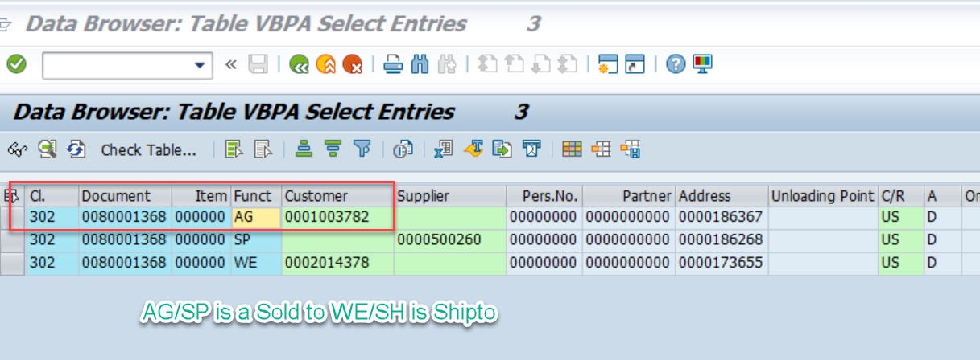

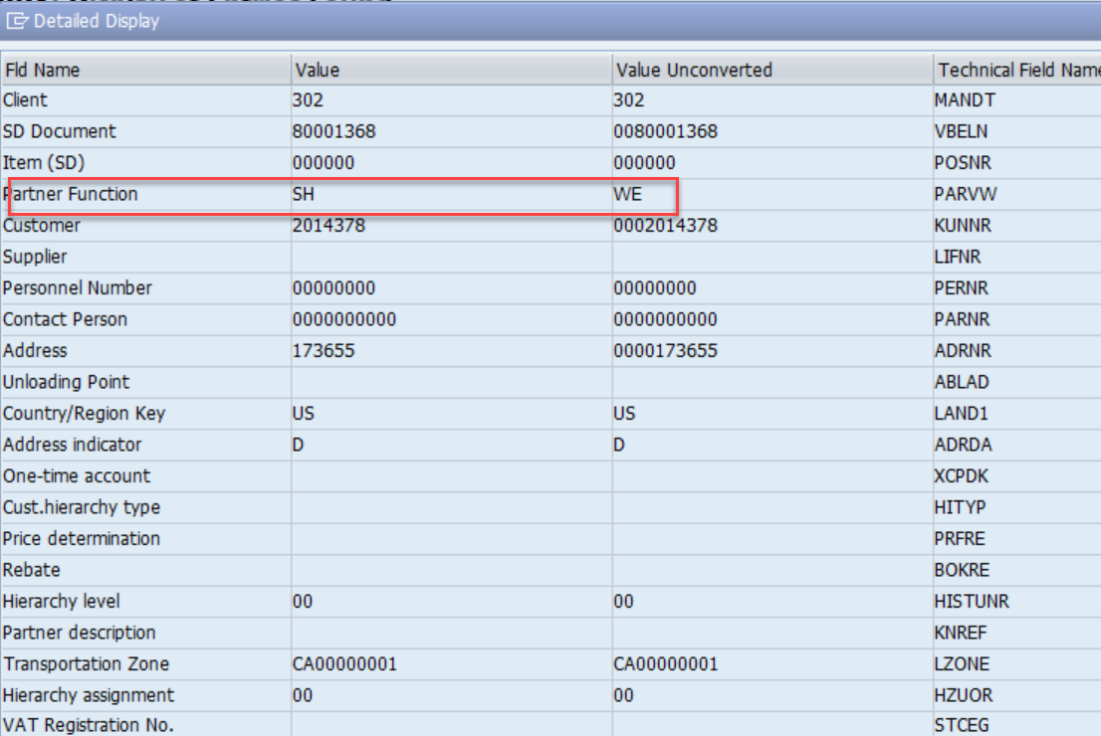

How to get the Shipment number

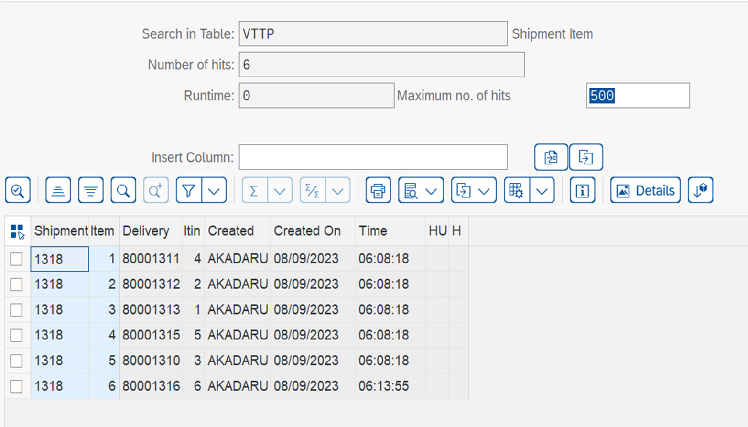

SCAC Code Link

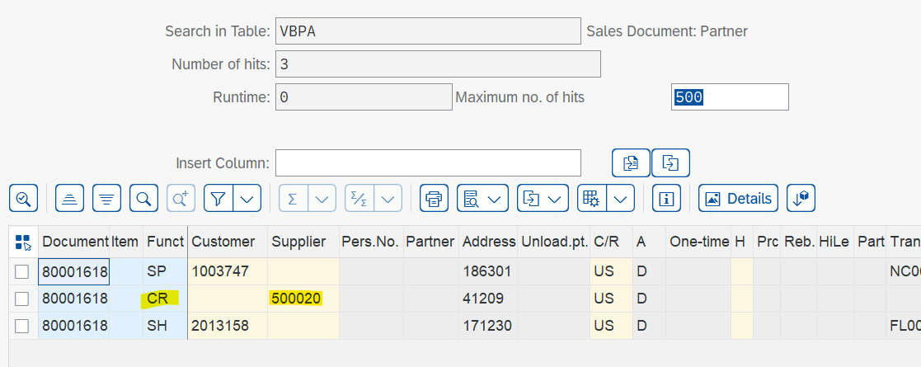

LFA1 - SCACD

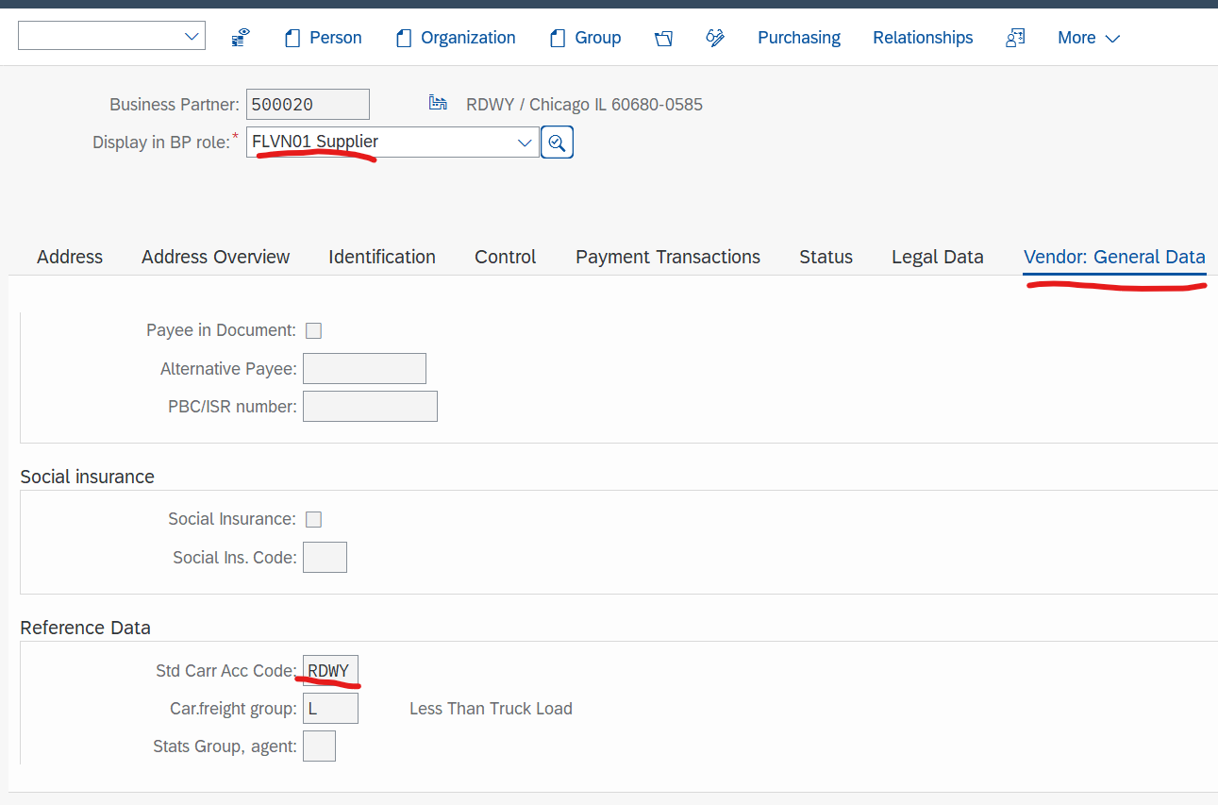

Customer UPC Logic lips-ean11 is for upc

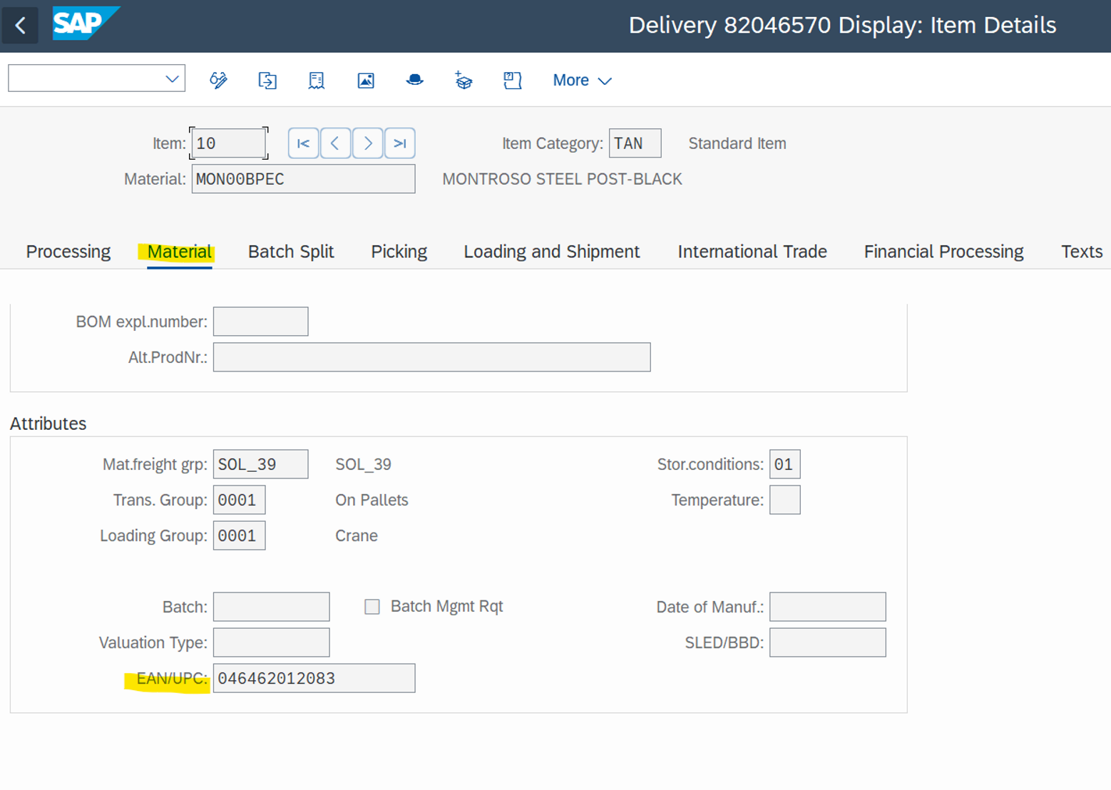

**Issues**

*[List Issues/Bugs identified]*